AI Answer Sheet Validator: MLOps Project Report
22K-4056, 22K-4008, 22K-8723

1. Introduction
This report documents the complete development and deployment lifecycle of the AI Answer Sheet Validator — an MLOps-driven system integrating NLP-based semantic scoring, containerized deployment, CI/CD automation, and scalable cloud hosting.
Throughout development, multiple cloud platforms and services were explored, including AWS EC2, S3, Render, and Vercel.
The system ultimately uses Render (Backend) and Vercel (Frontend) due to cost efficiency, speed, and ease of deployment compared to AWS Free Tier limitations.
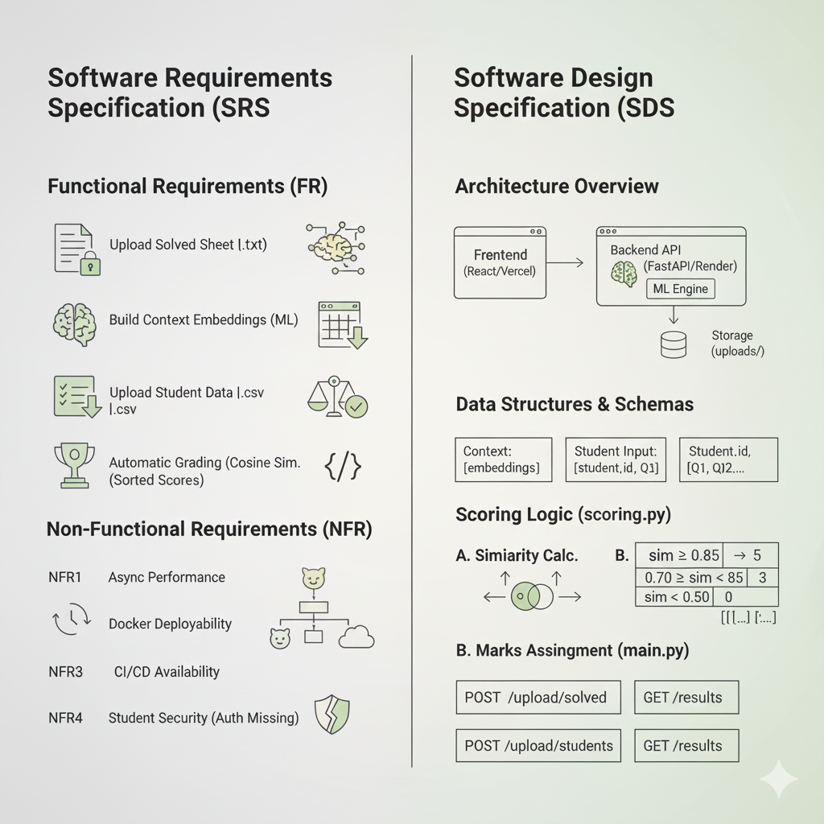

2. Architecture Overview
The project follows a modular architecture separated into two major components:
• Backend (FastAPI + Semantic Scoring)
• Frontend (React.js UI)
The backend exposes REST APIs for file uploads and answer grading, while the frontend serves as a clean interface for teachers to upload solved sheets and student responses.

3. MLOps Pipeline Stages & Integration

3.1 Version Control (Git & GitHub)
GitHub served as the central version-controlled repository ensuring collaborative development, pull requests, feature branching, and rollback capability.

3.2 Experimentation → Development
Local development was carried out using VS Code, virtual environments, and multiple testing workflows.
The scoring logic was built with Sentence-Transformers (paraphrase-MiniLM-L6-v2) and cosine similarity to award marks based on semantic match.

3.3 Containerization (Docker)
A full Dockerfile was created for the backend. Docker ensures consistent execution across machines, eliminating dependency conflicts.
Render uses this Dockerfile directly to deploy the backend — no manual Docker Desktop needed on the developer machine.

3.4 Cloud Deployment Evaluation
Initially, full deployment was attempted on AWS:
• AWS EC2 was used to run Docker containers
• S3 bucket used for frontend hosting
• CloudFront CDN explored for caching - payment limitations
• SSH-based deploy scripts tested
However, AWS Free Tier imposed resource and cost limitations, particularly with t2.micro instances running both backend and frontend containers simultaneously.
Performance and build times were slow, leading to a pivot toward more optimized platforms.

3.5 Final Deployment (Render + Vercel)
• Backend deployed on Render using Docker runtime
• Frontend deployed on Vercel with automatic builds
• Both platforms integrated with GitHub for seamless CI/CD
• Deploy Hooks configured for fully automated deployments after each push
This offers faster builds, zero infrastructure maintenance, and cost-efficient scalability.

4. Backend System Details
The backend (FastAPI) includes endpoints for:
• Uploading solved answer sheet .txt.pdf.docx
• Uploading student response CSVs, .csv.xlsx.xls
• Returning computed results
Grading uses embedding similarity to assign marks automatically.

5. Frontend System Details
The React frontend provides:
Login system (that nigarish has to give)
• File upload interface
• Live API connectivity
• Dynamic results display
Environment variables ensure the frontend communicates with the deployed backend.
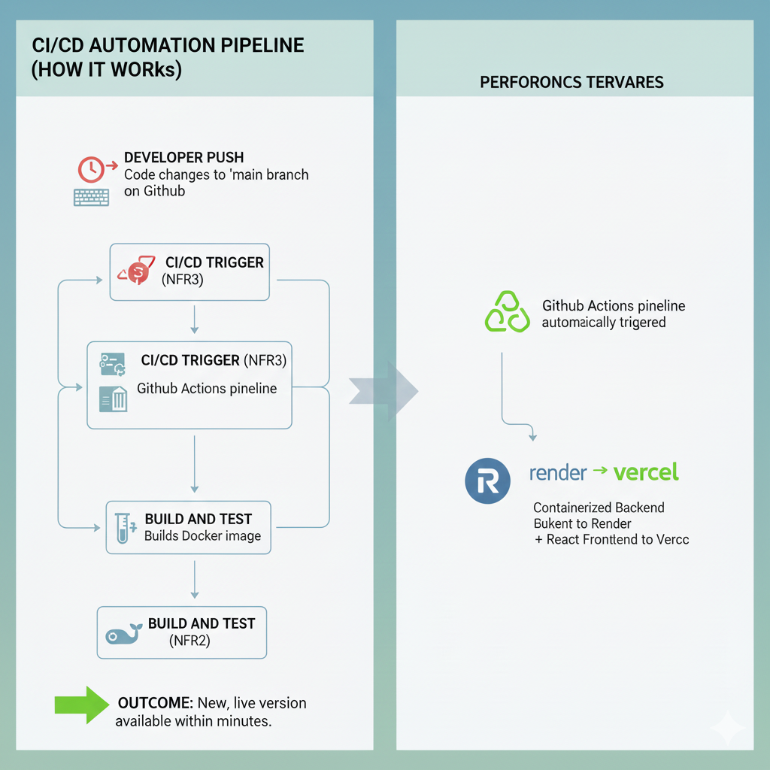

6. CI/CD Automation
Two GitHub Action workflows ensure automated deployment:
- Render Deploy Hook (backend)
- Vercel Deploy Hook (frontend)
The workflow triggers automatically on every push to the main branch.

7. Challenges Encountered
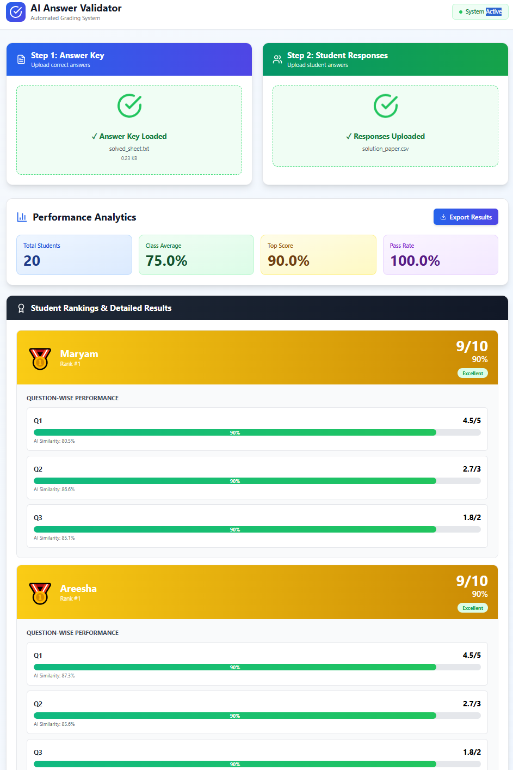
• AWS EC2 resource limits resulted in slow Docker builds
• npm ci failed on EC2 due to lockfile mismatch, requiring fallback to npm install
• File size (sentence-transformers) caused long install times on limited machines
• EC2 networking + firewall configurations required additional troubleshooting
These challenges justified the shift to Render + Vercel.

8. Final System Functionality
The final deployed system provides:
• Automatic answer key processing
• Semantic scoring using embeddings
• Per-student, per-question scoring
• Total score + ranking generation
• Cloud-hosted, publicly accessible frontend & backend
• CI/CD automation for updates

9. Conclusion
This MLOps project successfully demonstrates cloud deployment, containerization, semantic NLP evaluation, and automation pipelines.
The decision to move from AWS → Render + Vercel highlights practical engineering judgment in optimizing for resource limitations, deployment speed, and reliability.

